**Hospital Management System - SQL Project**

**Step 1: Analyze Requirements**

**Purpose**: Manage patients, doctors, appointments, treatments.

**Users**: Admin, Doctors, Receptionists, Patients.

**Entities**: Department, Doctor, Patient, Appointment, Treatment.

**Step 2: ER Diagram Design**

**Entities**:

- Department(dept_id, dept_name)

Doctor(doctor_id, name, specialization, email, dept_id)-

-Patient(patient_id, name, gender, DOB, contact)

-Appointment(appointment_id, doctor_id, patient_id, date, time, reason)

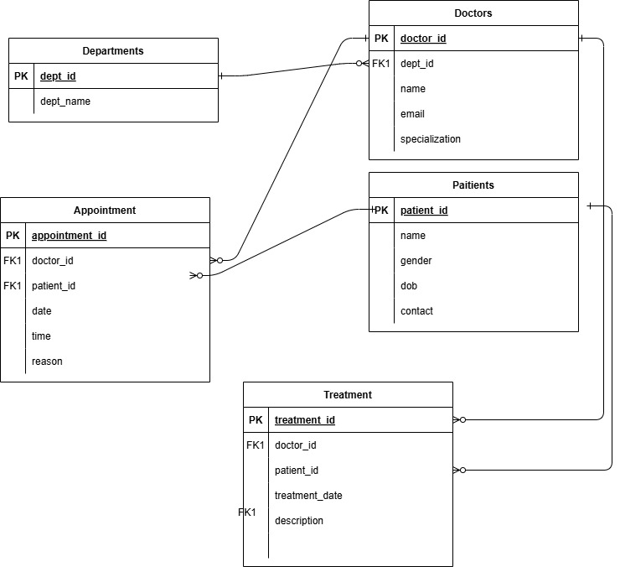-Treatment(treatment_id, patient_id, description, treatment_date, doctor_id)

**Step 3: Normalization**

**1NF**: Each table has atomic values (no lists, no repeating groups).  
**2NF**: All non-key attributes depend on the full primary key.  
**3NF**: No transitive dependencies (i.e., non-key attributes don’t depend on other non-key attributes).  
  
**Step 4: SQL Code (Schema)  
  
--** Departments

CREATE TABLE departments (

dept_id INT PRIMARY KEY AUTO_INCREMENT,

dept_name VARCHAR(100) NOT NULL

);

-- Doctors

CREATE TABLE doctors (

doctor_id INT PRIMARY KEY AUTO_INCREMENT,

name VARCHAR(100),

specialization VARCHAR(100),

email VARCHAR(100) UNIQUE,

dept_id INT,

FOREIGN KEY (dept_id) REFERENCES departments(dept_id)

);

-- Patients

CREATE TABLE patients (

patient_id INT PRIMARY KEY AUTO_INCREMENT,

name VARCHAR(100),

gender ENUM('Male', 'Female', 'Other'),

DOB DATE,

contact VARCHAR(20)

);

-- Appointments

CREATE TABLE appointments (

appointment_id INT PRIMARY KEY AUTO_INCREMENT,

doctor_id INT,

patient_id INT,

date DATE,

time TIME,

reason VARCHAR(255),

FOREIGN KEY (doctor_id) REFERENCES doctors(doctor_id),

FOREIGN KEY (patient_id) REFERENCES patients(patient_id)

);

-- Treatments

CREATE TABLE treatments (

treatment_id INT PRIMARY KEY AUTO_INCREMENT,

patient_id INT,

description TEXT,

treatment_date DATE,

doctor_id INT,

FOREIGN KEY (patient_id) REFERENCES patients(patient_id),

FOREIGN KEY (doctor_id) REFERENCES doctors(doctor_id)

### ); Step 5: Insert Sample Data

-- Departments

INSERT INTO departments (dept_name) VALUES

('Cardiology'), ('Neurology'), ('Orthopedics'), ('Pediatrics');

-- Doctors

INSERT INTO doctors (name, specialization, email, dept_id) VALUES

('Dr. Ali Omar', 'Cardiologist', 'ali.omar@hospital.com', 1),

('Dr. Sara Nabil', 'Neurologist', 'sara.nabil@hospital.com', 2),

('Dr. Hani Fawzy', 'Orthopedic Surgeon', 'hani.fawzy@hospital.com', 3),

('Dr. Mona Salem', 'Pediatrician', 'mona.salem@hospital.com', 4);

-- Patients

INSERT INTO patients (name, gender, DOB, contact) VALUES

('Ahmed Mohamed', 'Male', '1990-03-15', '0551234567'),

('Laila Youssef', 'Female', '1985-07-22', '0552345678'),

('Karim Adel', 'Male', '2000-11-01', '0553456789'),

('Noha Said', 'Female', '1995-04-10', '0554567890');

-- Appointments

INSERT INTO appointments (doctor_id, patient_id, date, time, reason) VALUES

(1, 1, '2025-05-10', '09:00:00', 'Chest pain'),

(2, 2, '2025-05-11', '11:00:00', 'Migraine'),

(4, 4, '2025-05-12', '10:30:00', 'Child fever');

-- Treatments

INSERT INTO treatments (patient_id, description, treatment_date, doctor_id) VALUES

(1, 'Prescribed heart medication', '2025-05-10', 1),

(2, 'MRI scan and medication', '2025-05-11', 2),

(4, 'Fever reducer prescribed', '2025-05-12', 4);

**Step 6: SQL Queries**-- 1. List all patients and their assigned doctor names

SELECT p.name AS patient, d.name AS doctor

FROM appointments a

JOIN patients p ON a.patient_id = p.patient_id

JOIN doctors d ON a.doctor_id = d.doctor_id;

-- 2. Number of appointments per department

SELECT dept_name, COUNT(*) AS total_appointments

FROM appointments a

JOIN doctors d ON a.doctor_id = d.doctor_id

JOIN departments dp ON d.dept_id = dp.dept_id

GROUP BY dept_name;

-- 3. Show all treatments given to a patient

SELECT p.name AS patient, t.description, t.treatment_date

FROM treatments t

JOIN patients p ON t.patient_id = p.patient_id

WHERE p.name = 'Ahmed Mohamed';

-- 4. Upcoming appointments for a specific doctor

SELECT a.date, a.time, p.name AS patient

FROM appointments a

JOIN patients p ON a.patient_id = p.patient_id

WHERE a.doctor_id = 1

ORDER BY a.date, a.time;